# User and Group in Linux

## Create a Group in Ubuntu

You can create a new group on the Ubuntu system by running the following command:

*$*sudo groupadd test_group

In the above command, the ‘test_group’ is the name of the new group.

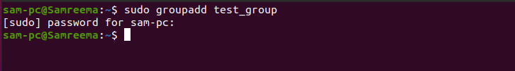

## Adding an Existing User to a Group in Ubuntu

To add a user that is already created on your Ubuntu machine and you want to assign a group to this existing user, run the following command to do this:

*$*sudo usermod -a -G groupname username

For example, the ‘sam-pc’ is existing on our system and we want to add this user to a group ‘test_group’. To do so, change the above command into the following form:

*$*sudo usermod -a -G test_group sam-pc



When you execute the above ‘usermod’ command, it does not show you any output on the terminal screen on successful command execution. That means the user is added to a group successfully. When you add a user into the group, you need to append the ‘-a’ option. If you do not add the ‘-a’ option, the user will be removed or eliminated from any groups not listed after the option ‘-G’.

## Create a New User and Add in Multiple Groups in Ubuntu

If you want to create a new user and add into a group by using just single command, use the ‘useradd’ command to add a new user and then add this user into the primary and secondary group by using the following syntax:

*$*sudo useradd -g group -G group1,group2 username

In the following example, we have created a new user with the name ‘Samrina’ and assigned multiple groups. The primary group is ‘users’ and the secondary groups are ‘sudo, sam-pc’.

*$*sudo useradd -g users -G sudo,sam-pc Samrina

## 

## Add an Existing Ubuntu User into Multiple Groups

To add an existing user into the multiple groups in the Ubuntu system, you can use the ‘usermod’ command followed by option ‘-G’, enter the name o the groups which will be separated by commas as follows:

*$*sudo usermod -a -G first_group, second_group username

Let’s take an example, to add an existing user ‘Samrina’ into multiple groups such as ‘sam-pc, sudo, sambashare’, run the below-mentioned command:

*$*sudo usermod -a -G sam-pc, sudo, sambashare Samrina

## 

## Change User’s Primary Group in Ubuntu

By using the `usermode` command followed by the option `-g`, you can change the user’s primary group.

*$*sudo usermod -g groupname username

In the following example, we changed the primary group of a user ‘Samrina’ to ‘test_group’ by running the below-mentioned command:

*$*sudo usermod -g test_group Samrina

## 

## Display User’s Groups Details in Ubuntu

You can display a complete user’s group information, such as a user belonging to which group. To perform this task, the following id command is used followed by the username:

*$*id username

For example, we want to display all group information of a user ‘sam-pc’.

*$*id Samrina

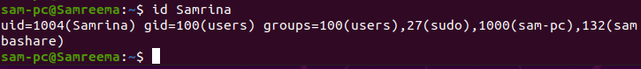

As you can observe in the above output, the user belongs to different groups. Here, the user’s primary group is ‘users’ and it is also a member of other supplementary groups that are ‘sudo, sam-pc, and sambashare’ which are shown in the above screenshot.

When you use the ‘group’ command followed by the username, it displays the user’s supplementary groups.

*$*groups sam-pc



If you will not pass a username to the ‘group’ command, in this case, it will display the current logged in user’s group information as follows:

*$*groups

## 

## Display All Ubuntu System Groups

To view all system groups that are running on your Ubuntu system, use the following ‘getent’ command:

*$*getent group

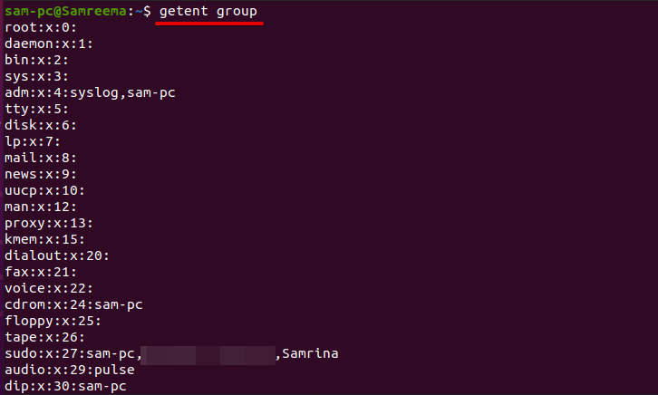

The above command displays all system groups on the terminal screen and also shows you the user’s account belongs to which group.

## Remove an Existing User from a Group in Ubuntu

To remove or eliminate a user from a group, execute the command ‘gpasswd’ followed by the option ‘-d’ on the terminal.

*$*sudo gpasswd -d username groupname

For example, we want to remove a user ‘Samrina’ from the ‘sambashare’ group, change the above command into the following form to do this task:

*$*sudo gpasswd -d Samrina sambashare

## 

## Delete a Group in Ubuntu

Use the following command ‘groupdel’ along with ‘groupname’, to delete an existing user’s group.

*$*sudo groupdel groupname

## 